**Faculty Directory for Multi Universities**

**Design Document**

**Version 1.0**



**Group Id: S21025A8D8 (BC180404438)**

**Supervisor Name : Saima Jamil**

**Revision History**

|  |  |  |  |
| --- | --- | --- | --- |
| **Date (dd/mm/yyyy)** | **Version** | **Description** | **Author** |
| **25/05/2021** | **1** | The purpose of this document is to describe the implementation of “Faculty Directory for Multi Universities".   Design documentation is a collection of documents and resources that covers all aspects of your product design. Documentation should include information about users, product features, and project deadlines; all essential implementation details ERD, Test Case, Database diagram, Sequence diagram, user interface | **BC180404438** |

**Table of Contents**

1. Introduction of Design Document page # 4
2. Entity Relationship Diagram (ERD) page # 6
3. Sequence Diagrams page # 7
4. Architecture Design Diagram page # 11
5. Class Diagram page # 12
6. Database Design page # 13
7. Interface Design page # 13
8. Test Cases page # 16

**Introduction of Design Document**

The project is to develop a Faculty Directory for Multi Universities web application; it provides great flexibility to buy easily computer accessories by online.

**Design documentation** is a collection of documents and resources that covers all aspects of your software design**.** The document gives a brief account of different operations that are performed by system describe the relationship between these operations within as well as outside the system. This phase represents the “How” phase. Details on computer programming languages and environments, machines, packages, application architecture, distributed architecture layering, memory size, platform, algorithms, data structures, global type definitions, interfaces and many other engineering details are the deliverables of design phase. This document presents the designs used or intended to be used in implementing the project.

* **Purpose of design document:**

The purpose of the Software Design Document is to provide a description of the design of a system fully enough to allow for software development to proceed with an understanding to be built and how it is expected to build. Design documents are also referred to as functional specifications or functional specifications documents, or functional requirements specifications

* **Benefits of design document:**

1. This makes help in keep an eye on project during its development.
2. It important for marketing and investors information materials.
3. It very simple and an effective way for communication with others whose are interested in product investment.
4. It helps to keep an eye on all aspects of application and it improvements regarding software product quality.
5. Focuses on maintenance of product, development of product & about transferring of knowledge to other developers & designers.
6. It is the critical component which brings the innovation in engineering life.

The design document of this web application includes:

* Entity Relationship Diagram (ERD)
* Sequence Diagram
* Architecture Design Diagram
* Class Diagram
* Database Design
* Interface Design
* Test Cases

**Entity Relationship Diagram (ERD)**

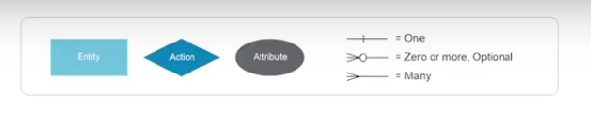

**Sequence Diagrams**









**Architecture Design Diagram**

**Class Diagram**

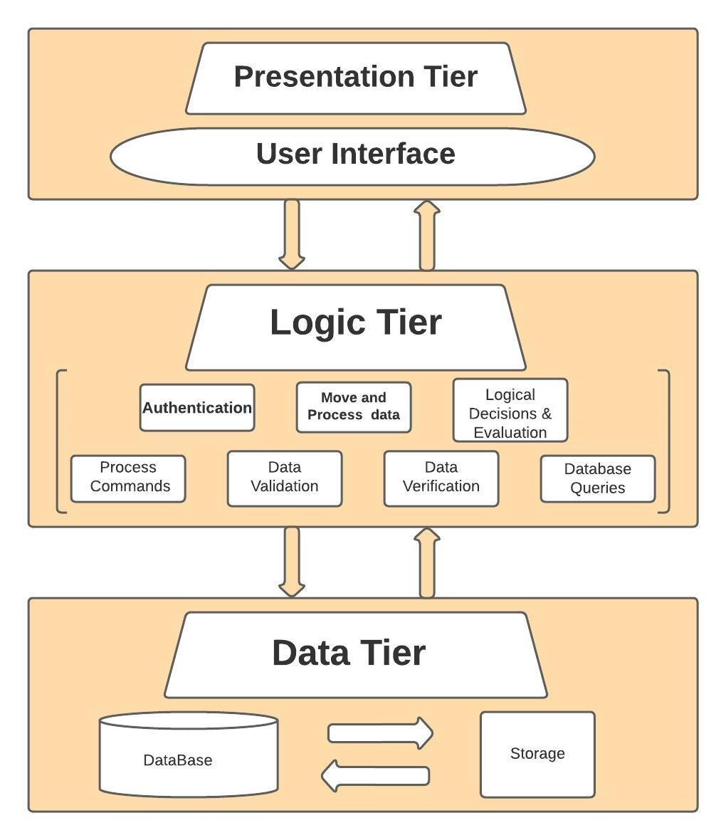



**Database Design**



**Interface Design**

* **Home Page (Detailed Search Criteria will be added in the bottom of Page)**

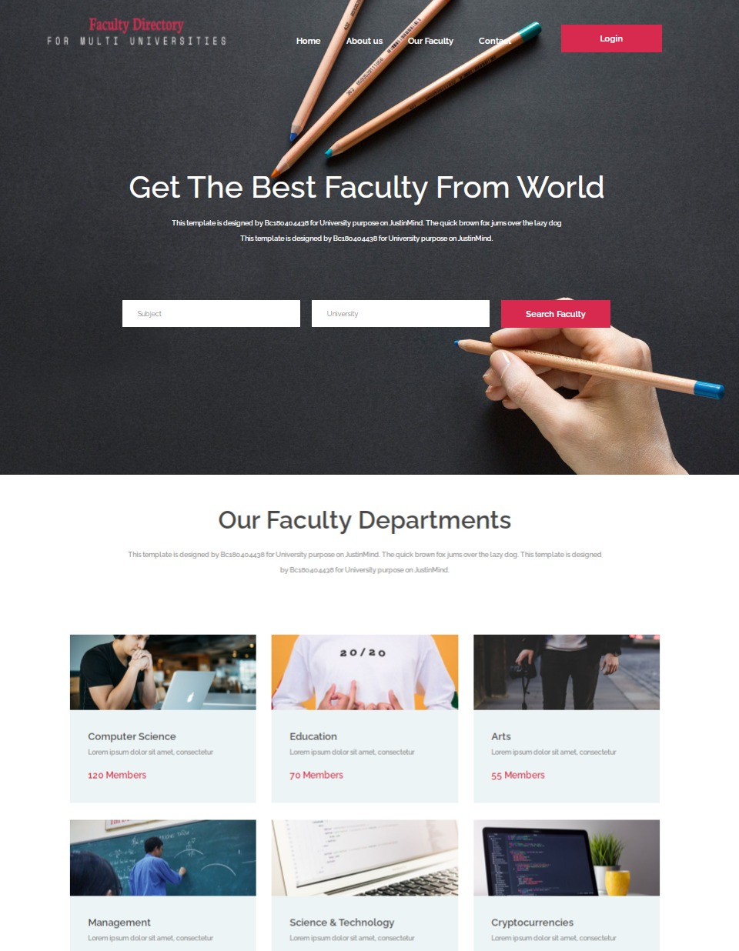

* **Sign In**

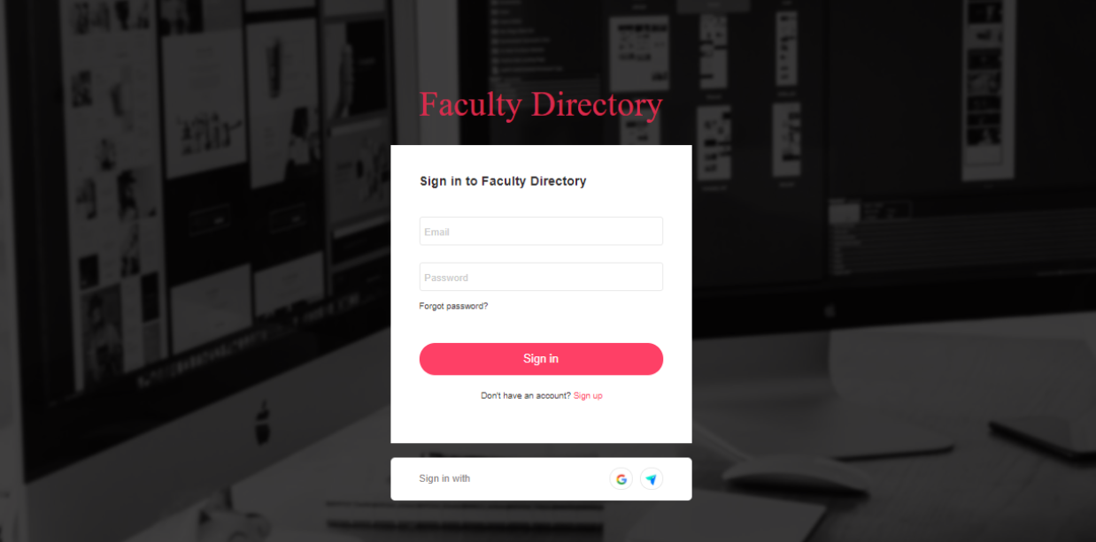

* **Register**

**Test** **Cases**

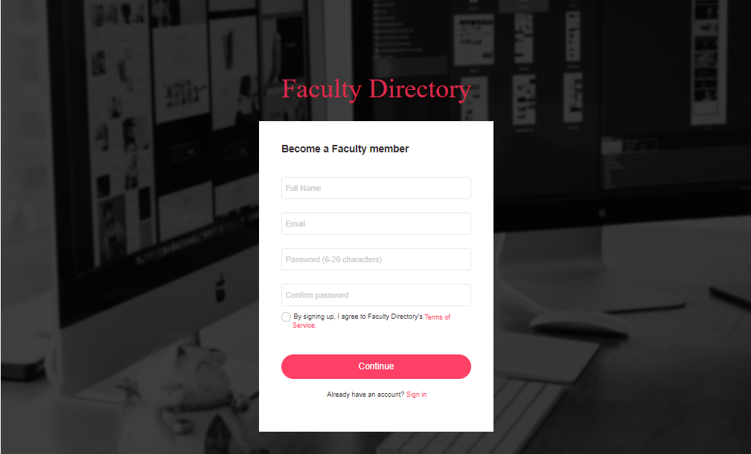

|  |  |
| --- | --- |
| **Test Case Title** | **Login** |
| Test Case Id | 1 |
| Actors | Admin & Faculty Member |
| Descriptions | User will be able to login into the system by using their username and password. |
| Pre-conditions | * User has a Valid Username. * User has a Valid Password. |
| Test Steps | 1. User navigates to the Login Page. 2. User enters the valid Username. 3. User enters the valid Password. 4. User clicks on “Login” button. 5. System validates the entered Username and Password 6. System navigates the user into the dashboard after successful Login. |
| Expected Results | User should be able to Login into the System. |
| Actual Results | User is redirected to the dashboard with the successful Login. |
| Status | Pass |
| Tested By | **S21025A8D8 (BC180404438)** |

|  |  |
| --- | --- |
| **Test Case Title** | **Register** |
| Test Case Id | 2 |
| Actors | Faculty Member |
| Descriptions | User who wants to Register with the system, will be registered by filling registration form. |
| Pre-conditions | * User must have information. * System should be connected to database. |
| Test Steps | 1. User navigates to the Registration Page. 2. User provides the required information for Registration. 3. User clicks on “Register” button. 4. System validates the entered information. 5. System will display “Registration Successful” message upon successful registration |
| Expected Results | User should be able to Register into the System. |
| Actual Results | User is registered successfully. |
| Status | Pass |
| Tested By | **S21025A8D8 (BC180404438)** |

|  |  |
| --- | --- |
| **Test Case Title** | **Manage Requests** |
| Test Case Id | 3 |
| Actors | Admin |
| Descriptions | User wants to manage the requests made by faculty members by registering themselves. User can accept and decline request . Upon accepting the request, faculty member will be able to login to the system. |
| Pre-conditions | * User must be logged into the system. * System should be connected to database. |
| Test Steps | 1. User will click “Manage Requests” button. 2. System will show available requests stored in system. 3. User will search/select request which he/she wants to manage. 4. User will click on Decline / Accept as he/she desires.. 5. System will display “Changes Saved Successfully” after updating. |
| Expected Results | User should be able to the manage the request made by Faculty Member |
| Actual Results | User has managed the requests successfully |
| Status | Pass |
| Tested By | **S21025A8D8 (BC180404438)** |

|  |  |
| --- | --- |
| **Test Case Title** | **Add Faculty Details** |
| Test Case Id | 4 |
| Actors | Faculty Member |
| Descriptions | User wants to add their details into the system, will add their details using user interactive form. |
| Pre-conditions | * User must be logged into the system. * System should be connected to database. |
| Test Steps | 1. User will click “Add Details” button. 2. System will show user interactive form to fill by user. 3. User will fill all the necessary field and will click “Submit” 4. System will display “Changes Saved Successfully” after updating. |
| Expected Results | User should be able to the add the details in the system |
| Actual Results | User added details successfully. |
| Status | Pass |
| Tested By | **S21025A8D8 (BC180404438)** |

|  |  |
| --- | --- |
| **Test Case Title** | **Manage Faculty Details** |
| Test Case Id | 5 |
| Actors | Faculty Member & Admin |
| Descriptions | User wants to update/Delete/ details into the system, will add their details using user interactive form. |
| Pre-conditions | * User must be logged into the system. * System should be connected to database. |
| Test Steps | 1. User will click “Mange Details” button. 2. System will show user saved details. 3. User will be able to Delete/Update the information 4. After, user will click “Submit” 5. System will display “Changes Saved Successfully” after updating. |
| Expected Results | User should be able to the manage the faculty details in the system |
| Actual Results | User managed faculty details successfully. |
| Status | Pass |
| Tested By | **S21025A8D8 (BC180404438)** |

|  |  |
| --- | --- |
| **Test Case Title** | **Search Faculty Details** |
| Test Case Id | 6 |
| Actors | Guest/Visitor |
| Descriptions | User wants to search faculty details in the home page of Online Faculty Directory Website. User will be able to search through several ways i.e. Filtering by name, university, alphabets etc. |
| Pre-conditions | * System should be running properly * System should be connected to database. |
| Test Steps | 1. User will land on homepage. 2. System will show top faculty member. 3. User will be able to search by using different criteria. 4. User will be able to type “keywords” and will click “Search” 5. System will display faculty accordingly. |
| Expected Results | User will be able to view/search faculty details. |
| Actual Results | User has searched faculty members successfully. |
| Status | Pass |
| Tested By | **S21025A8D8 (BC180404438)** |